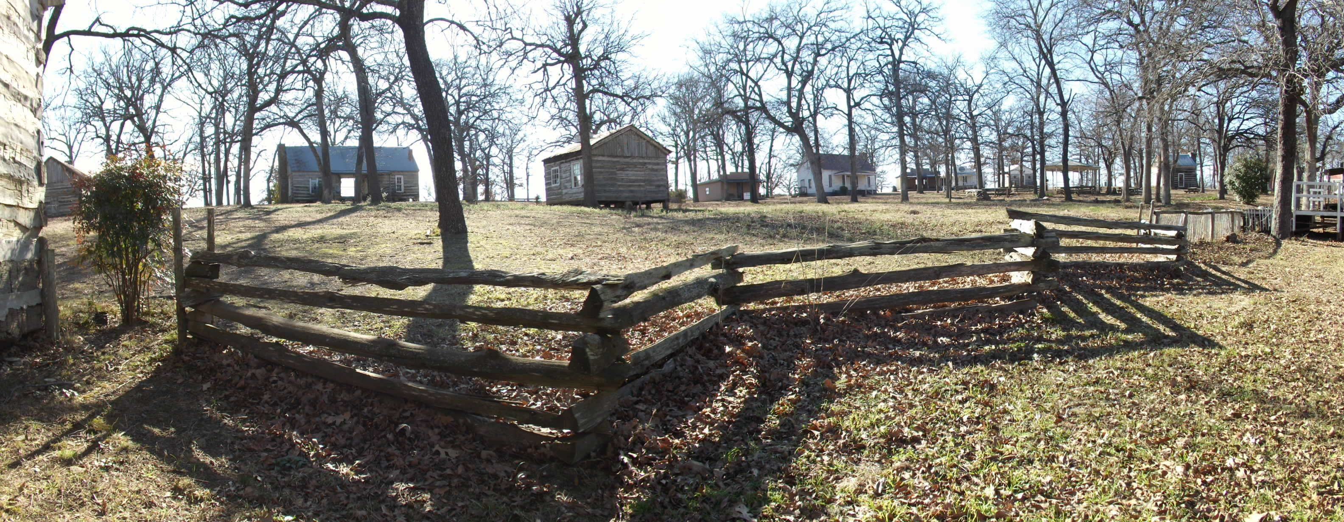
FRONTIER DAYS
VENDOR APPLICATION

DATE: Saturday, March 2nd from 9am to 6pm
(you’re also welcome to set up Sunday, March 3rd from 9am to 12 noon at no additional charge.)
PLACE: Loy Lake Park, Denison, Texas
Grayson Co. Frontier Village & Museum
111 R.C. Vaughan Rd., Exit 67 off HWY 75.

DEADLINE FOR APPLICATIONS IS FEBURARY 20TH, 2019

Business of Group Name ______________________________________________________________
EIN or TIN _______________________________ Contact Name _________________________
Mailing Address _______________________________________________________________________
Email _____________________________________ Phone __________________________________
Facebook page or website ____________________________________________________________
Product being sold: ____________________________________________________________________
___________________________________________________________________________________________

* Booths measure 12’X12’. There is a two (2) booth maximum per vendor.
* Vendors are responsible for bringing their own tents, tables & chairs. All outside vendors must have a canopy.
* Electricity is limited and must be paid for in advance. The charge for electricity is $10 per booth, and you must provide your own heavy-duty extension cord.
* No guarantees are made for placement, but requests are filled when possible.
* There is no subletting of booths. If you cancel at least 72 hours in advance, your booth fee is refundable. “No show,” and those that give less then 72 hours notice are non-refundable.
* In the event of rain, this event will be rescheduled.
* No alcohol is to be consumed on the premises.
* No tobacco products are to be used inside the booths. Smoking areas are available throughout the venue.
* Anyone displaying aggressive or disruptive behavior towards either staff, customers, or other vendors is subject to removal from the event and no refund will be issued.
* Set up begins at 7am. All vehicles must be unloaded and moved to designated parking spaces no later than 8:30 am.

By signing here you agree to abide by the rules of this event and all state and local laws in the area.
Please sign here ________________________________________________________________

No booths are considered to be registered for this event until payment has been received.
Please choose from the list below the option that you are paying for. All checks should be made out to Grayson County Frontier Village, or G.C.F.V. and mailed to; PO Box 646, Denison, TX 75021. Credit cards will be processed through Square if you are listing your card number below, or you may pay via PayPal at PayPal.Me/gcfrontiervillage

☐ Non-profit organization. (must provide certificate) $ 10.00
Number of booths ______ Amount paid _________
☐ 12X12 booth $ 25.00
Number of booths ____ Amount paid ______
☐ Electricity (per booth) $ 10.00
Number of booths ____ Amount paid ______

Credit card payment:
Name on card ________________________ Zip code _______________
Card # __________________________________________________________________
Expiration date ___________________ CVV _____________
Amount to be charged ______________________

